**169. Module Introduction**

**1) Understanding Observables:**

* Observable can be thought of as a data source
* In angular project Observable is an object we import from a third party package – RxJs
* Observable follows the observable design pattern .
* So we have an observable and an observer. In between we have a stream – a timeline
* On this timeline we can have multiple events emitted by the observable

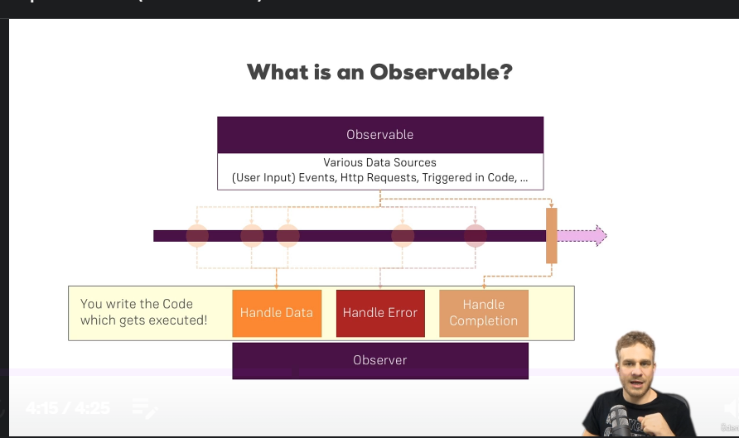

* **Observable:**
* Hence an observable could emit data, because we trigger it to do so.
* Eg: It could be connected to a button. Hence when a button is clicked, an event in a data package is emitted automatically
* Or as the Angular HTTP service does it – it is connected to a http request. So when the response emits, the response is emitted as a data package.
* **Observer:**
* It is the subscribe function we saw earlier
* **Three ways of handling data packages:**
* A) Handle Normal Data B) Handle Error C) Handle Completion of an observable
* It is in these hooks, your code gets executed.
* So you can determine, what should happen if I receive a new data package.
* We can also use Observables to handle asynchronous tasks. Because User events, http requests are asynchronous tasks, where we don’t know when they will happen and how long they will happen.